UNIFIED MODELLING LANGUAGE

An Overview of UML

The UML is a language for

- Visualizing
- Specifying
- Constructing
- Documenting

These are the artifacts of a software-intensive system.

A conceptual model of UML:

The three major elements of UML are
- The UML’s basic building blocks
- The rules that dictate how those building blocks may be put together.
- Some common mechanisms that apply throughout the UML.

Basic building blocks of the UML

The vocabulary of UML encompasses three kinds of building blocks:
- Things
- Relationships
- Diagrams

Things are the abstractions that are first-class citizens in a model;
Relationships tie these things together;
Diagrams group the interesting collection of things.

Things in UML: There are four kind of things in the UML
- Structural things
- Behavioral things.
- Grouping things
- Annotational things

These things are the basic object oriented building blocks of the UML.They are used to write well-formed models.

STRUCTURAL THINGS

Structural things are the nouns of the UML models. These are mostly static parts of the model, representing elements that are either conceptual or physical. In all, there are seven kinds of Structural things.

Class:
A class is a description of a set of objects that share the same attributes, operations, relationships, and semantics. A class implements one or more interfaces.
Graphically a class is rendered as a rectangle, usually including its name, attributes and operations, as shown below.

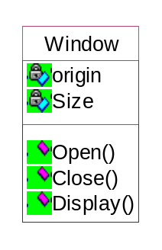

Interface:

An interface is a collection of operations that specify a service of a class or component. An interface describes the externally visible behaviour of that element.
Graphically the interface is rendered as a circle together with its name.

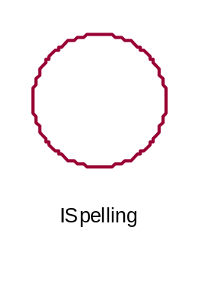

Collaboration:

Collaboration defines an interaction and is a society of roles and other elements that work together to provide some cooperative behavior that’s bigger than the sum of all the elements.
Graphically , a collavoration is rendered as an ellipse with dashed lines, usually including only its name as shown below.

Chain of Responsibility

Chain

Use Case:

Use case is a description of a set of sequence of actions that a system performs that yields an observable result of value to a particular things in a model.
Graphically, Use Case is rendered as an ellipse with dashed lines, usually including only its name as shown below.

Place Order

Active Class:

An active class is a class whose objects own one or more processes or threads and therefore can initiate control activity.
Graphically, an active class is rendered just like a class, but with heavy lines usually including its name, attributes and operations as shown below.

Event Management

Suspend()
Flush()

Component:

Component is a physical and replaceable part of a system that conforms to and provides the realization of a set of interfaces.
Graphically, a component is rendered as a rectangle with tabs, usually including only its name, as shown below.

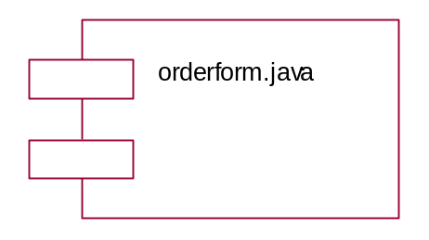

Node:

A Node is a physical element that exists at run time and represents a computational resource, generally having at least some memory and often, processing capability.
Graphically, a node is rendered as a cube, usually including only its name, as shown below.

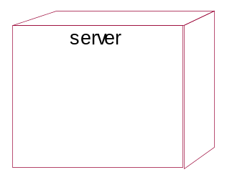

BEHAVIORAL THINGS

Behavioral Things are the dynamic parts of UML models. These are the verbs of a model, representing behavior over time and space.

Interaction:

An interaction is a behavior that comprises a set of messages exchanged among a set of objects within a particular context to accomplish a specific purpose.
Graphically, a message is rendered as a direct line, almost always including the name if its operation, as shown below.

Display

State Machine:
A state machine is a behavior that specifies the sequence of states an object ar an interaction goes through during its lifetime on response to events, together with its responses to those events.
Graphically, a state is rendered as arounded rectangle usually including its name and its sub-states, if any, as shown below.

Waiting

GROUPING THINGS

Grouping things are the organizational parts of the UML models. These are the boxes into which a modl can be decomposed.

Package:
A package is a general-purpose mechanism for organizing elements into groups.

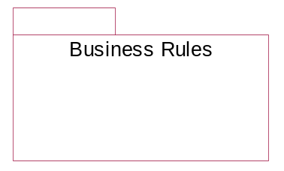

ANNOTATIONAL THINGS

Annotational things are the explanatory parts of the UML models.
Note:
A note is simply a symbol for rendering constraints and comments attached to an element or a collection of elements.
Graphically a note is rendered as a rectangle with dog-eared corner together, with a textual or graphical comment, as shown below.

RELATIONSHIPS IN THE UML:

There are four kinds of relationships in the UML:
- Dependency
- Association
- Generalization
- Realization

CLASS DIAGRAMS

Class diagrams are the most common diagrams found in modeling object-oriented systems. A class diagram shows a set of classes, interfaces, and collaborations and their relationships. Graphically, a class diagram is a collection of vertices and arcs.

Contents:
Class Diagrams commonly contain the following things:
Classes
Interfaces
Collaborations
Dependency, generalization and association relationships

USE CASES
Use Case diagrams are one of the five diagrams in the UML for modeling the dynamic aspects of systems(activity diagrams, sequence diagrams, state chart diagrams and collaboration diagrams are the four other kinds of diagrams in the UML for modeling the dynamic aspects of systems). Use Case diagrams are central to modeling the behavior of the system, a sub-system, or a class. Each one shows a set of use cases and actors and relationships.

Common Properties:
A Use Case diagram is just a special kind of diagram and shares the same common properties, as do all other diagrams- a name and graphical contents that are a projection into the model. What distinguishes a use case diagram from all other kinds of diagrams is its particular content.

Contents
Use Case diagrams commonly contain:
Use Cases
Actors
Dependency, generalization, and association relationships

Like all other diagrams, use case diagrams may contain notes and constraints.
Use Case diagrams may also contain packages, which are used to group elements of your model into larger chunks. Occasionally, you will want to place instances of use cases in your diagrams, as well, especially when you want to visualize a specific executing system.

INTERACTION DIAGRAMS

An Interaction diagram shows an interaction, consisting of a set of objects and their relationships, including the messages that may be dispatched among them.
Interaction diagrams are used for modeling the dynamic aspects of the system.

A sequence diagram is an interaction diagram that emphasizes the time ordering of the messages. Graphically, a sequence diagram is a table that shows objects arranged alongs the X-axis and messages, ordered in increasing time, along the Y-axis and messages, ordered in increasing time, along the Y-axis.

Contents
Interaction diagrams commonly contains:
Objects
Links
Messages

Like all other diagrams, interaction diagrams may contain notes and constraints.

SEQUENCE DIAGRAMS:

A sequence diagram is an interaction diagram that emphasizes the time ordering of the messages. Graphically, a sequence diagram is a table that shows objects arranged along the X-axis and messages, ordered in increasing time, along the Y-axis.
Typically you place the object that initiates the interaction at the left, and increasingly more sub-routine objects to the right. Next, you place the messages that these objects send and receive along the Y-axis , in order of increasing time from top to the bottom. This gives the reader a clear visual cue to the flow of control over time.

Sequence diagrams have two interesting features:
- There is the object lifeline. An object lifeline is the vertical dashed line that represents the existence of an object over a period of time. Most objects that appear in the interaction diagrams will be in existence for the duration of the interaction, so these objects are all aligned at the top of the diagram, with their lifelines drawn from the top of the diagram to the bottom.
- There is a focus of the control. The focus of control is tall, thin rectangle that shows the period of time during which an object is performing an action, either directly or through the subordinate procedure. The top of the rectangle is alignes with the action; the bottom is aligned with its completion.

ACTIVITY DIAGRAM

An Activity Diagram is essentially a flow chart showing flow of control from activity to activity. They are used to model the dynamic aspects of as system .They can also be used to model the flow of an object as it moves from state to state at different points in the flow of control.

An activity is an ongoing non-atomic execution with in a state machine.Activities ultimately result in some action,which is made up of executable atomic computations that result in a change of state of distinguishes a usecase diagram from all other kinds of diagrams is its particular content.

Contents
Use case diagrams commonly contain:
Use cases
Actors
Dependency,generalizations,and association relationships

Like all other diagrams use case diagrams may contain notes and constraints
Use case diagrams may also contain packages which are used to group elements of your model into larger chunks.Occasionally you will want to place instances of usecases of your diagrams,as well especially when you want to visualize a specific executing system.

Interaction diagrams
An interacation diagram shows an interaction,consisting of a set of objects and their relationships,including the messages that may be dispatched among them.

A sequence diagram is an interaction diagram that emphasizes the time ordering of messages.Graphically, a sequence diagram is a table that shows objects along the X-Axis and messages along the Y-Axis.

Contents
Interaction diagrams commonly contains:
Objects
Links
Messages
Like all other diagrams,interaction diagrams may contain notes and constraints.

STATE CHART DIAGRAMS
A state chart diagram shows a state machine .State chart diagrams are used to model the dynamic aspects of the system.For the most part this involves modeling the behaviour of the reactive objects.A reactive object is one whose behaviour is best characterized by its response to events dispatched from outside its context.A reactive object has a clear lifeline whose current behaviour is affected by its past.

A statechart diagram show a statemachine emphasizing the flow of control from state to state.A state machine is a behaviour that specifies the sequence of states an object goes through during its life time in response to events together with its response to those events.A state is a condition in the life of the object during which it satifies some conditions,performs some activity or wait for some events. An event is a specification of a significant occurrence that has a location in time and space.

Graphically a state chart diagram is a collection of vertices and arcs. State chart diagram commonly contain:
Simple states and Composite states.
Transitions, including events and actions.

UML Diagrams

        - Class Diagrams

Overall Class Diagram

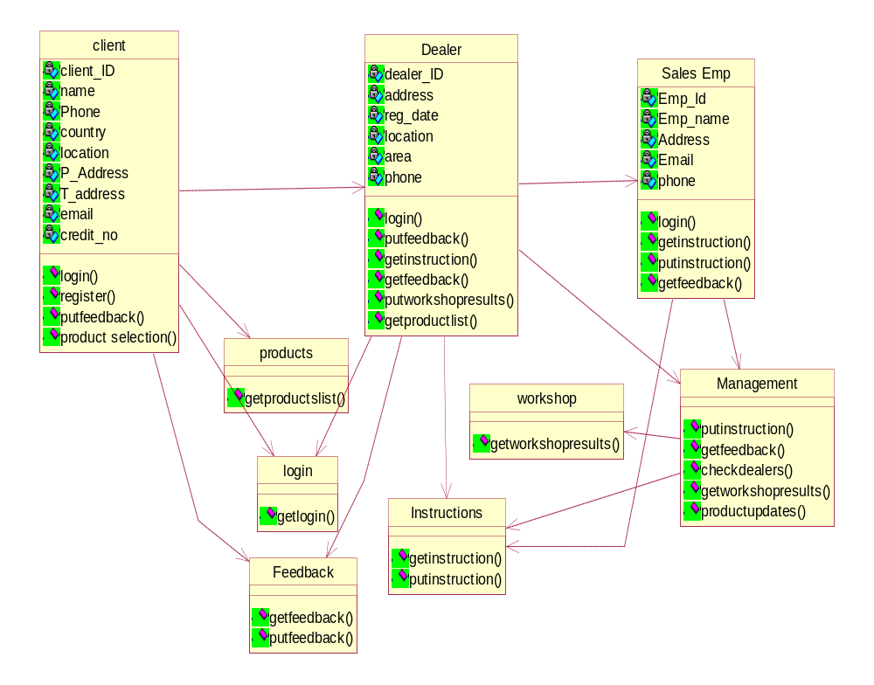

        - Use case Diagrams

Dealer transaction
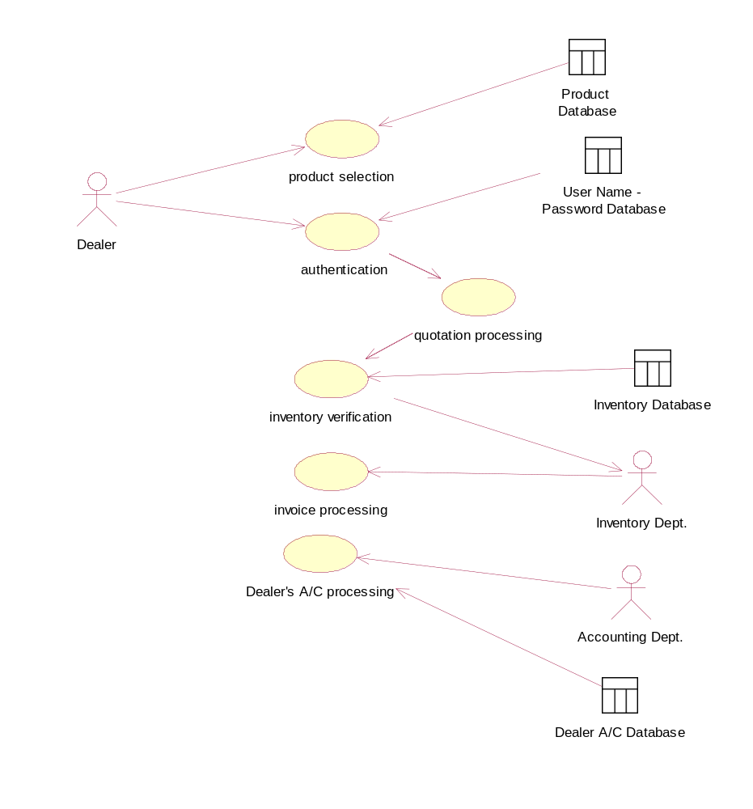

        - Sequence Diagrams

Sequence Diagram For Sales Workflow

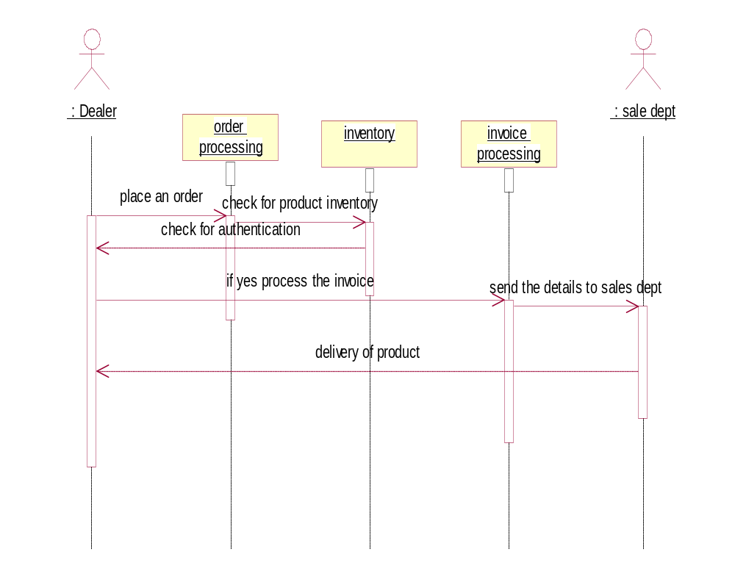

Sequence Diagram For Instruction Workflow

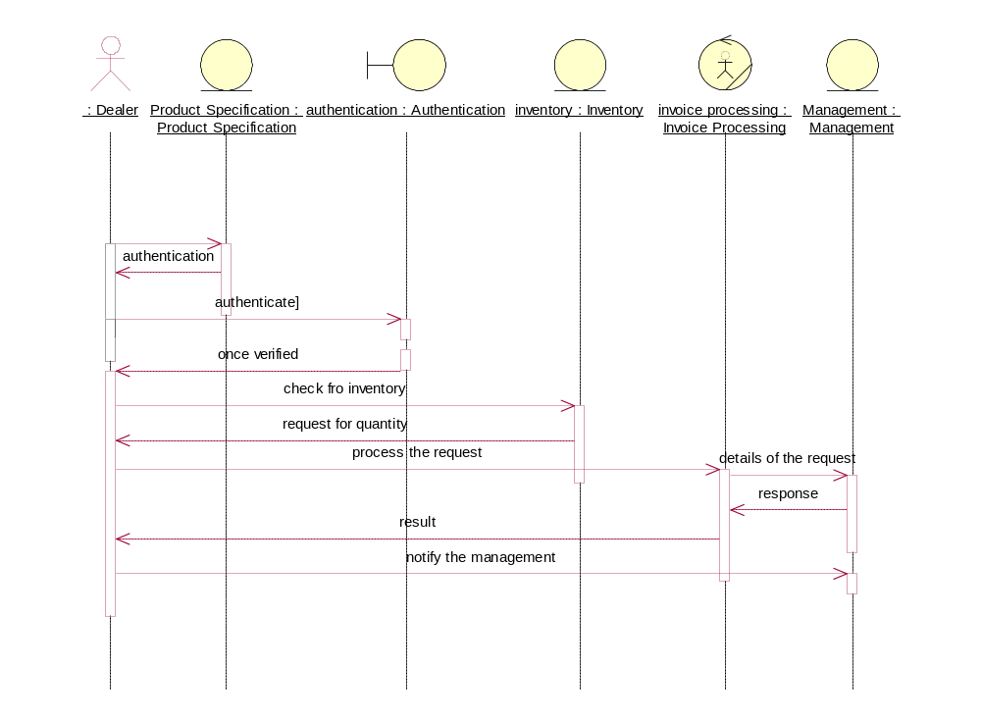

Sequence Diagram for Feedback Workflow

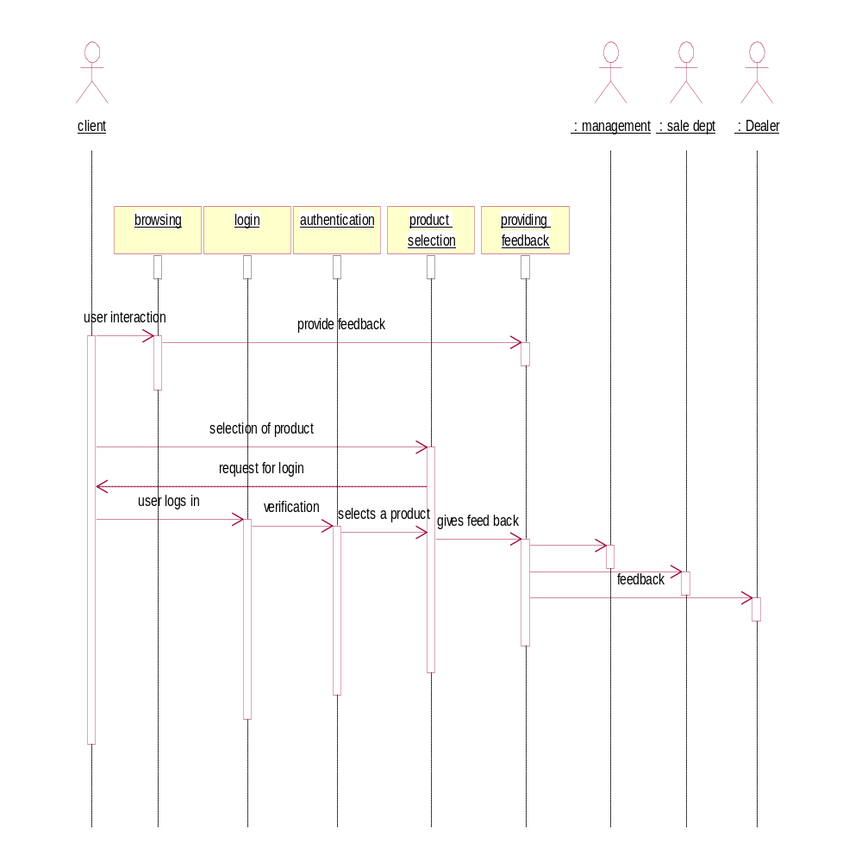

Sequence Diagram For Workshop WorkFlow

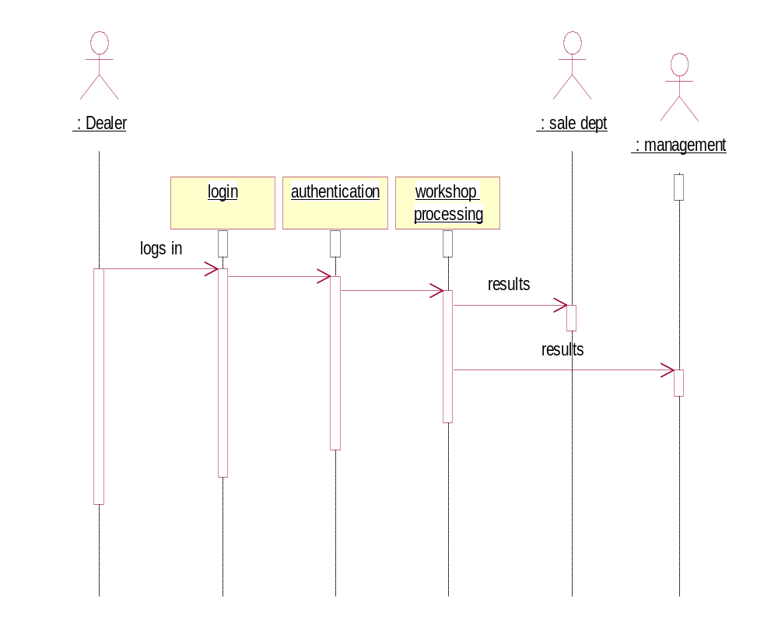

Dealer Workshop

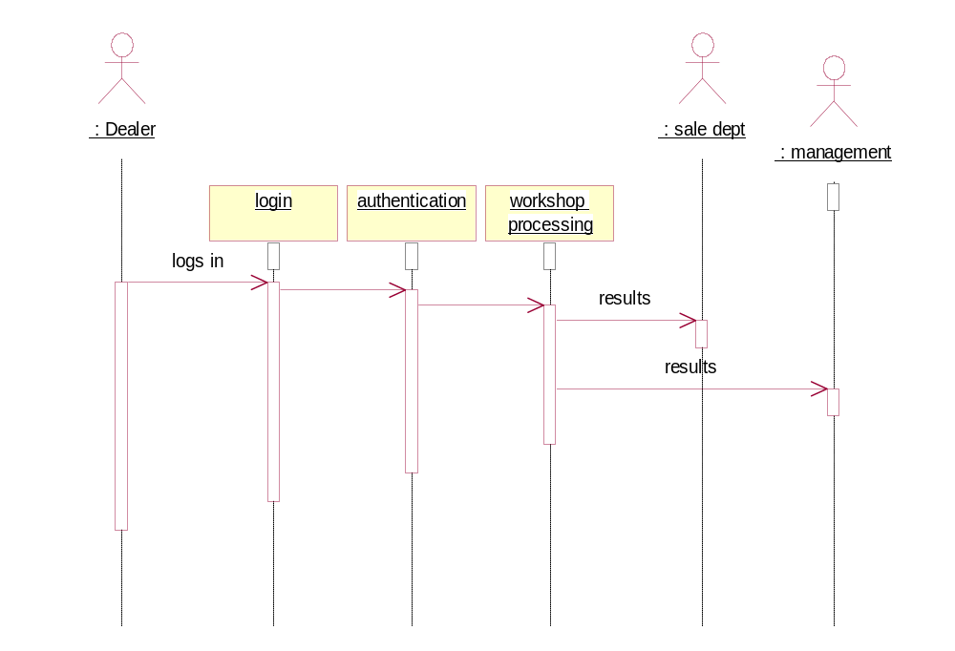

Dealer Transactions

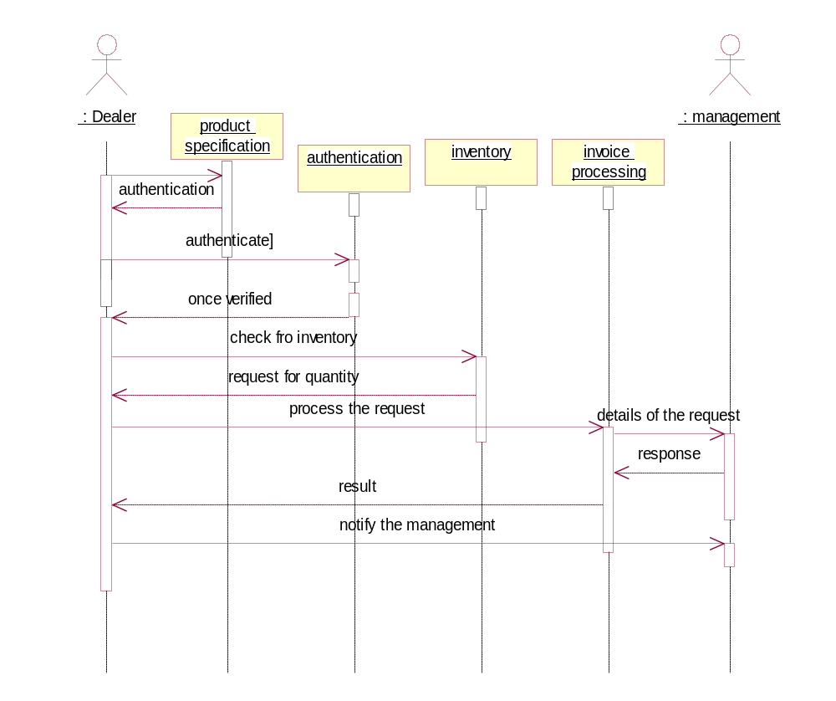

        - Collaboration Diagrams

Collaboration Diagram for Sales Workflow

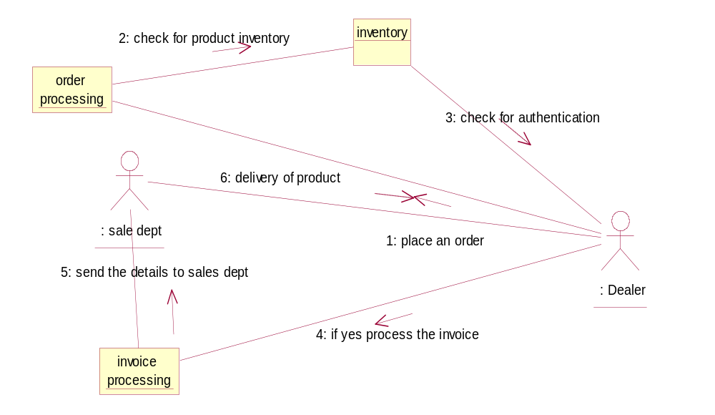

Collaboration Diagram for Instructions workflow

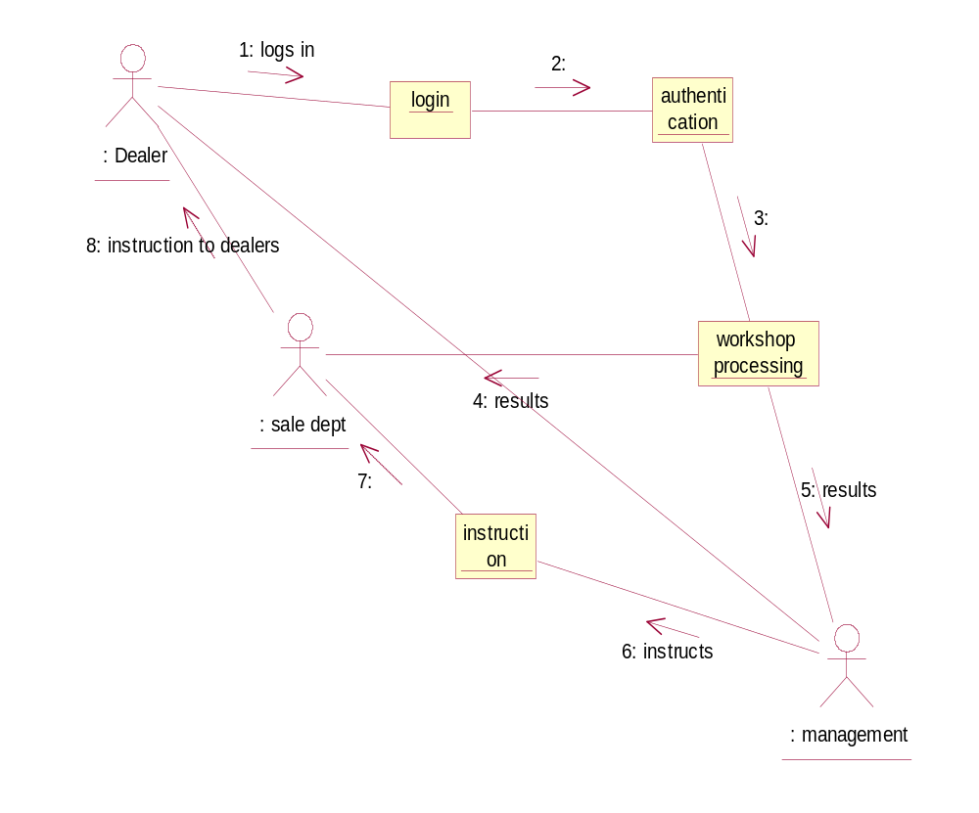

Collaboration Diagram For Feedback Workflow

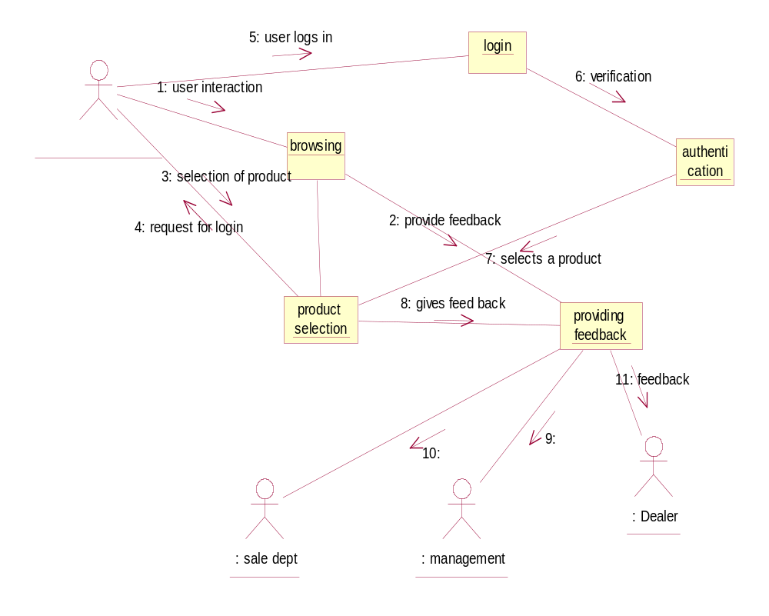

Collaboration Diagram For Workshop Workflow

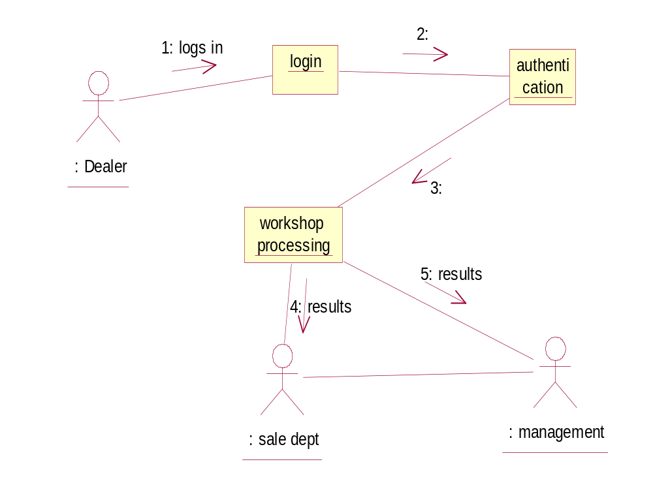

Dealer Transactions:

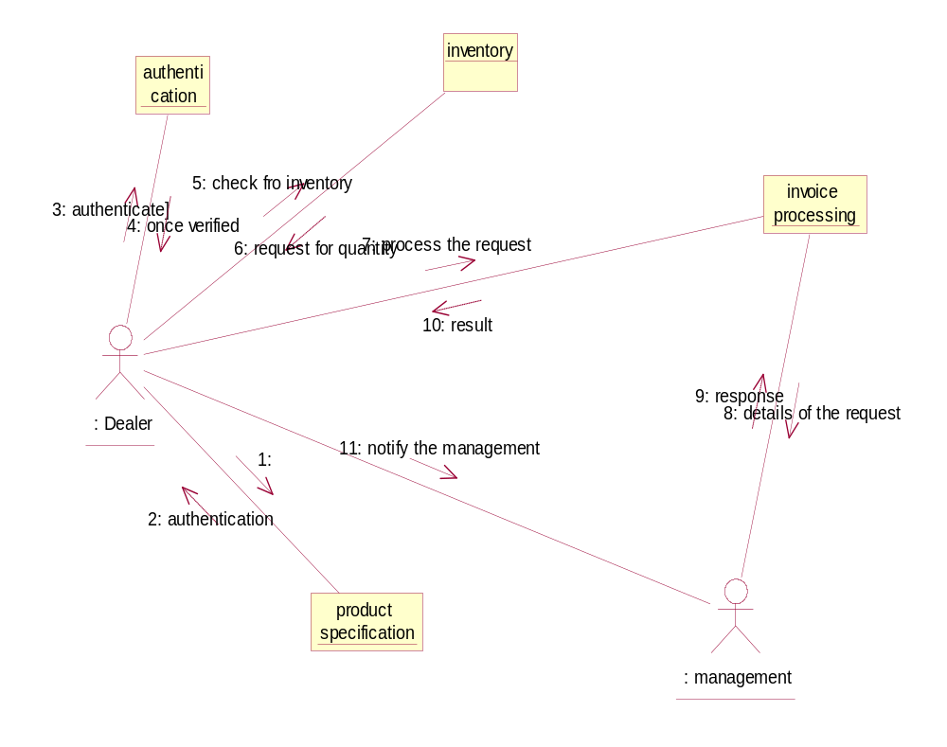

Client Transaction:

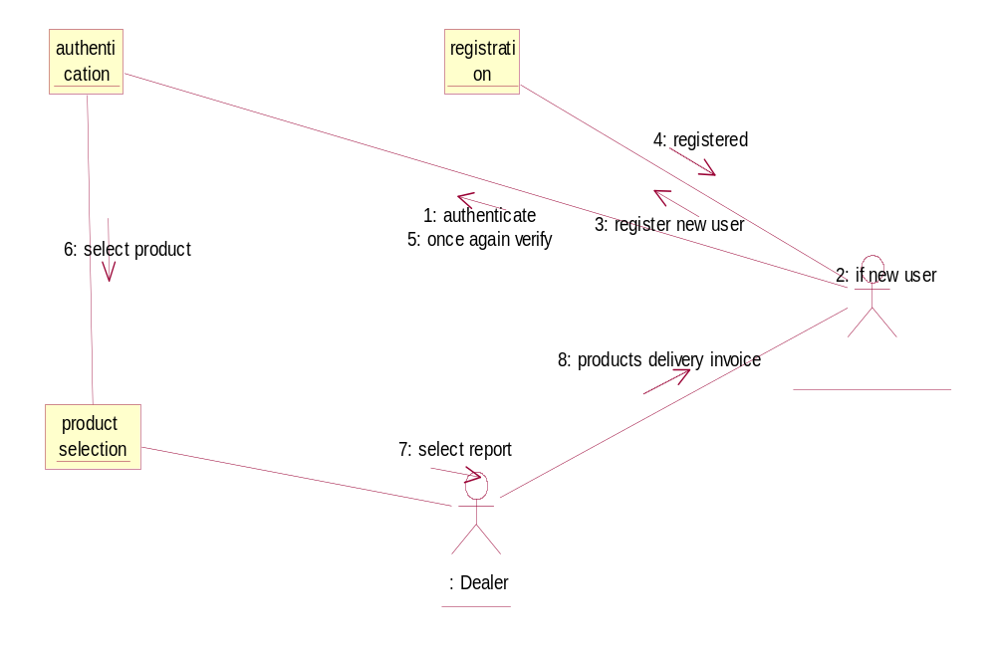

        - Activity Diagrams

Dealer’s activity diagram:
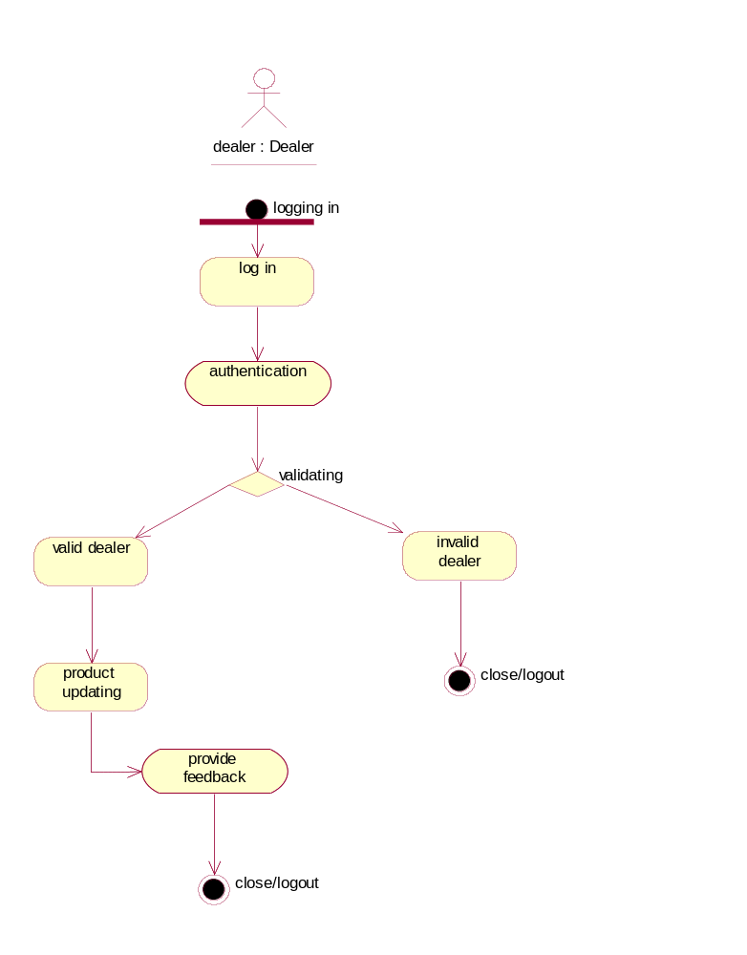

Sales Employee activity diagram:
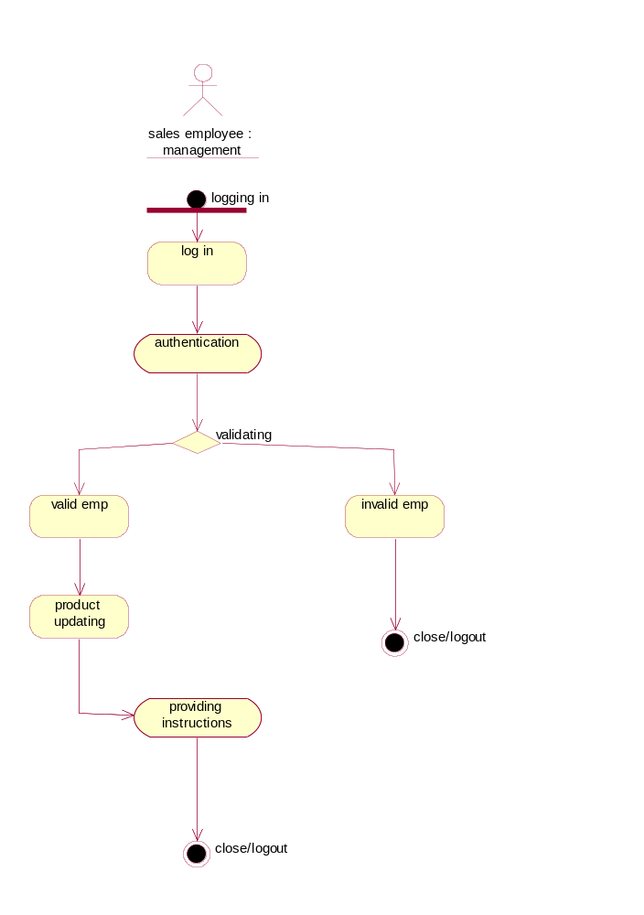
Client’s activity diagram:

